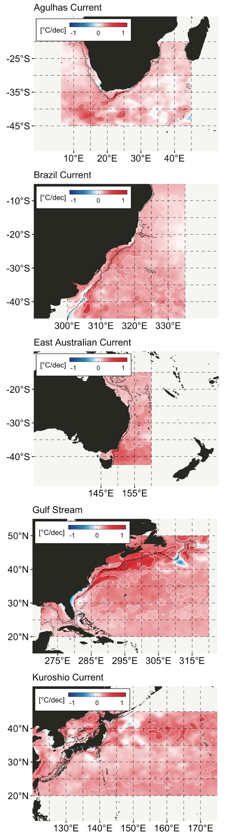**Figure 2.** The decadal trend in mean SST calculated over the period 1981-09-01 to 2018-09-30 (the time period has since been updated—redraw figure). The marine heat wave data show that the areas of greatest heatwave activity are not actually collocated with the current trajectories, but occur adjacent to the main path. Is this also true for the trend in mean SST? Trend fitted with Generalised Least Squares withcorARMA(form = ~ 1 | year, p = 2)

The rest of the analysis is based in the various MHW metrics (see Hobday et al., 2016). A MHW is defined as “a prolonged discrete anomalously warm water event that can be described by its duration, intensity, rate of evolution, and spatial extent.” MHWs are calculated by finding the occasions that the SST exceeds a threshold in the probability distribution of the data (*i.e.* relative to the 90th percentile) calculated based on an 11-day wide moving mean smoother centred on each day of the year at each site (or pixel in the case of gridded data). These metrics include:

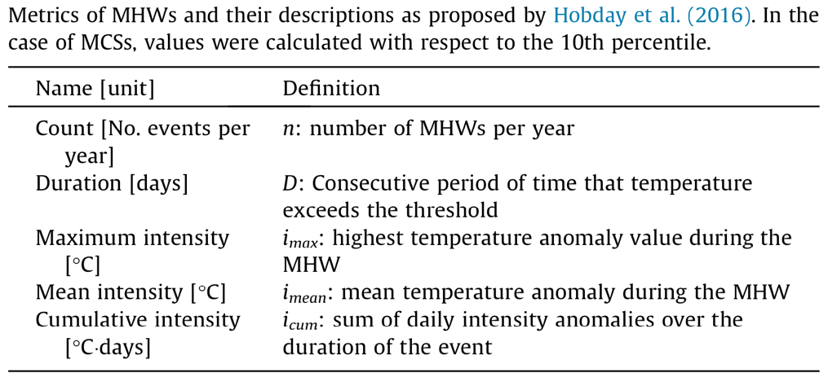

Below, events are counted when the SST on five consecutive days exceed the 90th percentile threshold based on a per-pixel climatology calculated from time series of 30 years in duration. Also, discrete anomalies with well-defined start and end dates, but with ‘breaks’ between events lasting ≤2 days followed by subsequent ≥5 day events, were considered as continuous events. The algorithm as implemented in our R code is flexible in the event definition, and we may specify counting events only when they last for 10 day, or we may be more or less conservative regarding the duration of breaks between events.

More details on the algorithm here: <https://robwschlegel.github.io/heatwaveR/index.html>

The figures that follow are based on spatial summaries of some of these metrics.

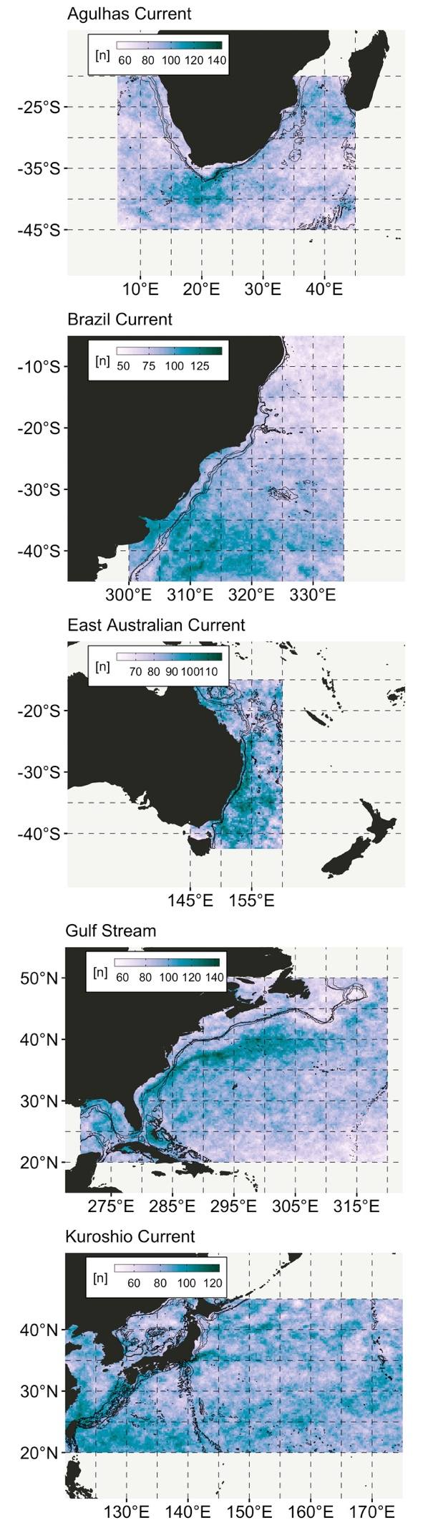**Figure 3.** The *total count* of MHWs in WBC-associated ocean regions over the period 1981-09-01 to 2018-09-30.

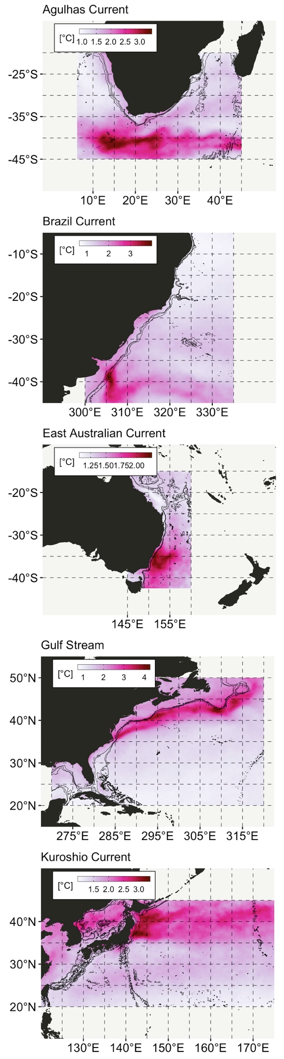**Figure 4.** Regional summaries of MHW *mean intensity* [°C] calculated as the mean over the period 1981-09-01 to 2018-09-30. Although the regions with the highest mean intensity seem to coincide with the current paths, closer scrutiny in Fig. xxx reveals a slight offset between mean current trajectory and MHW activity.

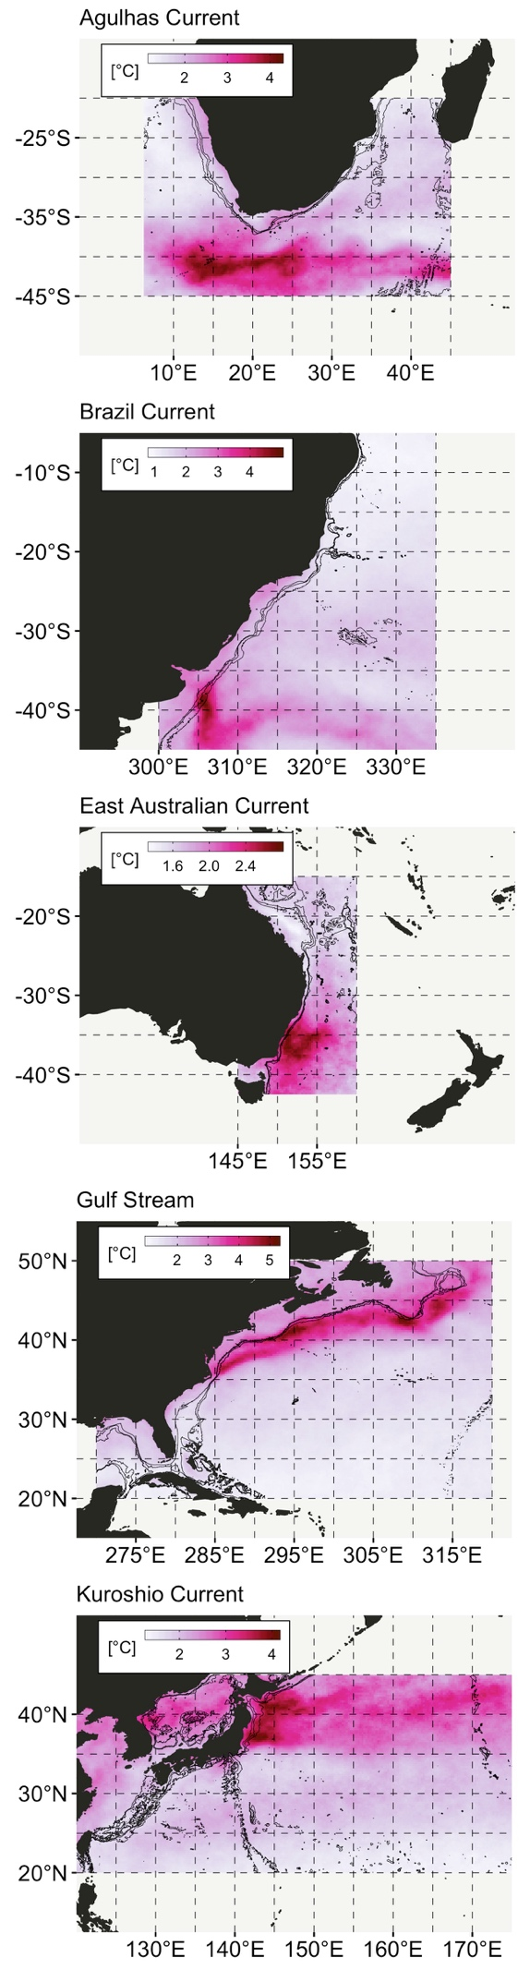**Figure 5.** As in Fig. 4, but showing the long-term mean *maximum intensity* [°C].

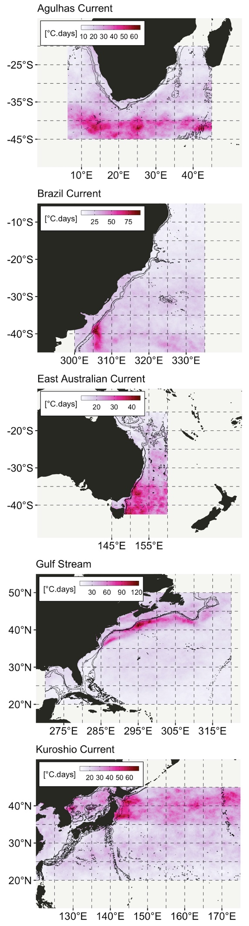**Figure 6.** As Fig. 4, but showing long-term mean *cumulative intensity* [°C.days].

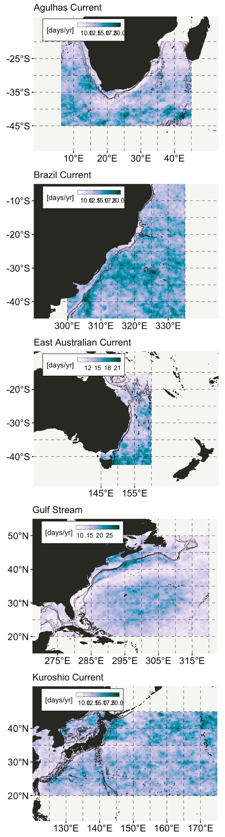**Figure 7.** As Fig.4, but showing the mean *duration* of MHWs [days].

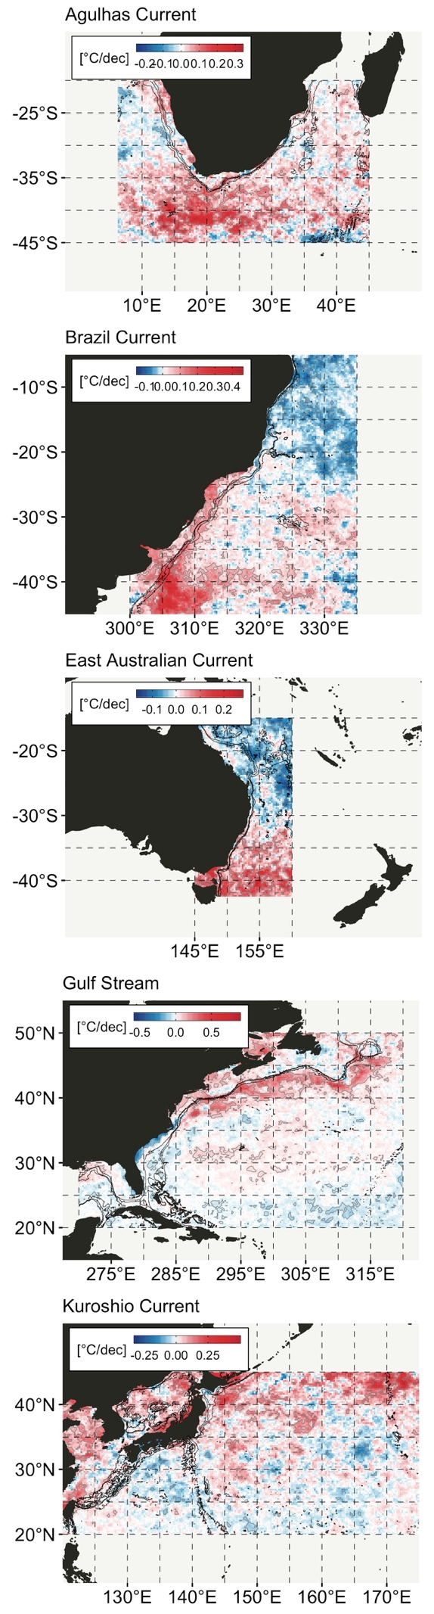**Figure 8.** Regional summaries of rate of change in MHW activity per decade; here specifically in the *trend in mean intensity* [°C/dec] over the period 1981-09-01 to 2018-09-30. Trends estimated using a simple linear regression.

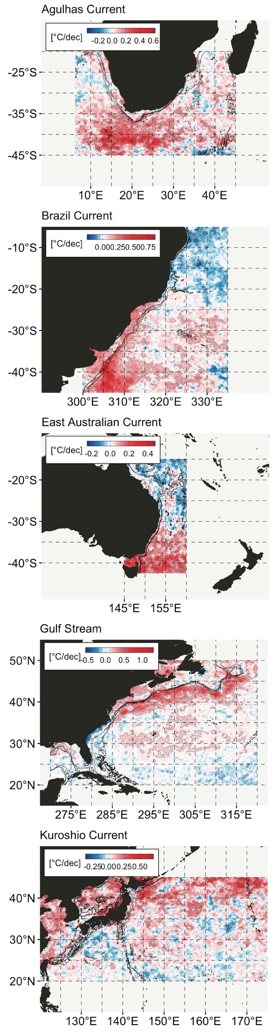**Figure 9.** *Trend in maximum intensity* [°C/dec]. See Fig. 8 for further details.

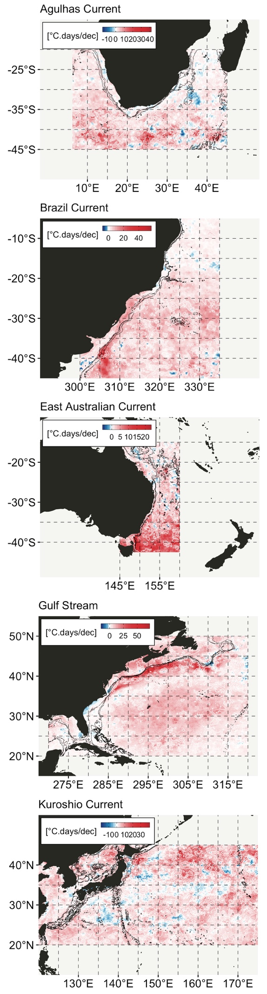**Figure 10.** *Trend in cumulative intensity* [°C.days/dec] (note: the incorrect unit is still shown in this figure, but it has been corrected in the R script). See Fig. 8 for further details.

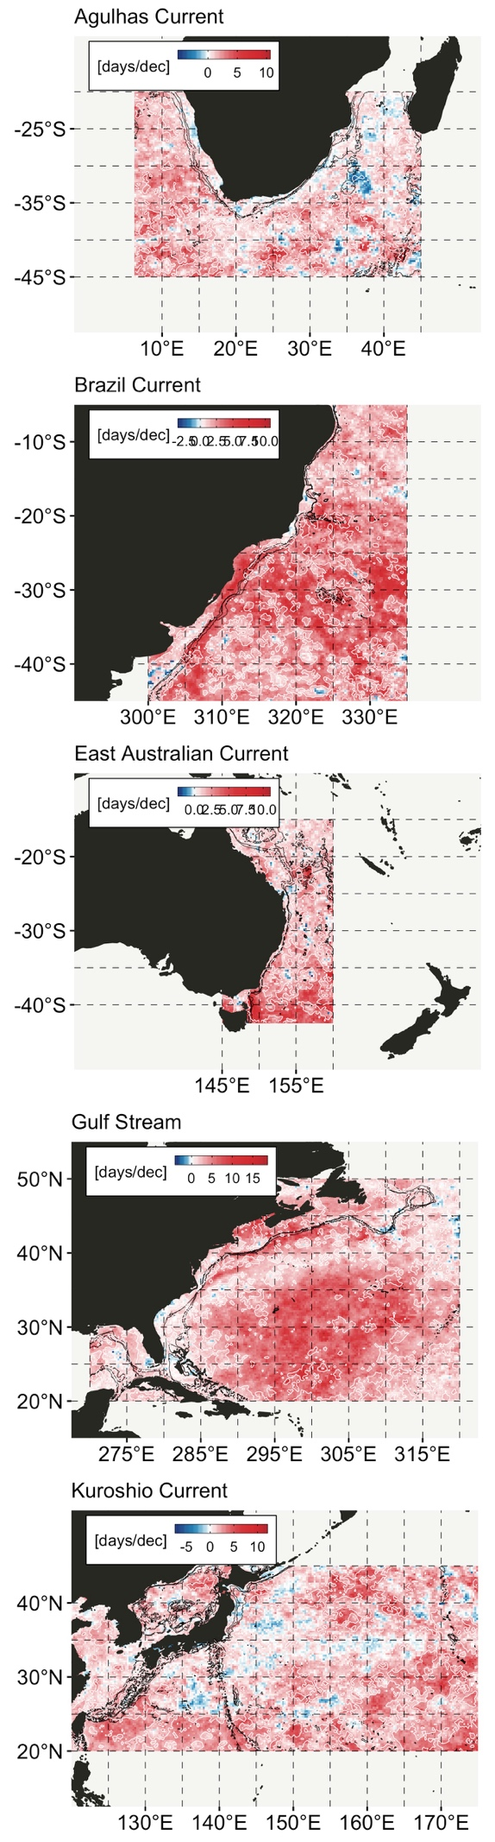**Figure 11.** *Trend in duration* [days/dec]. See Fig. 8 for further details.

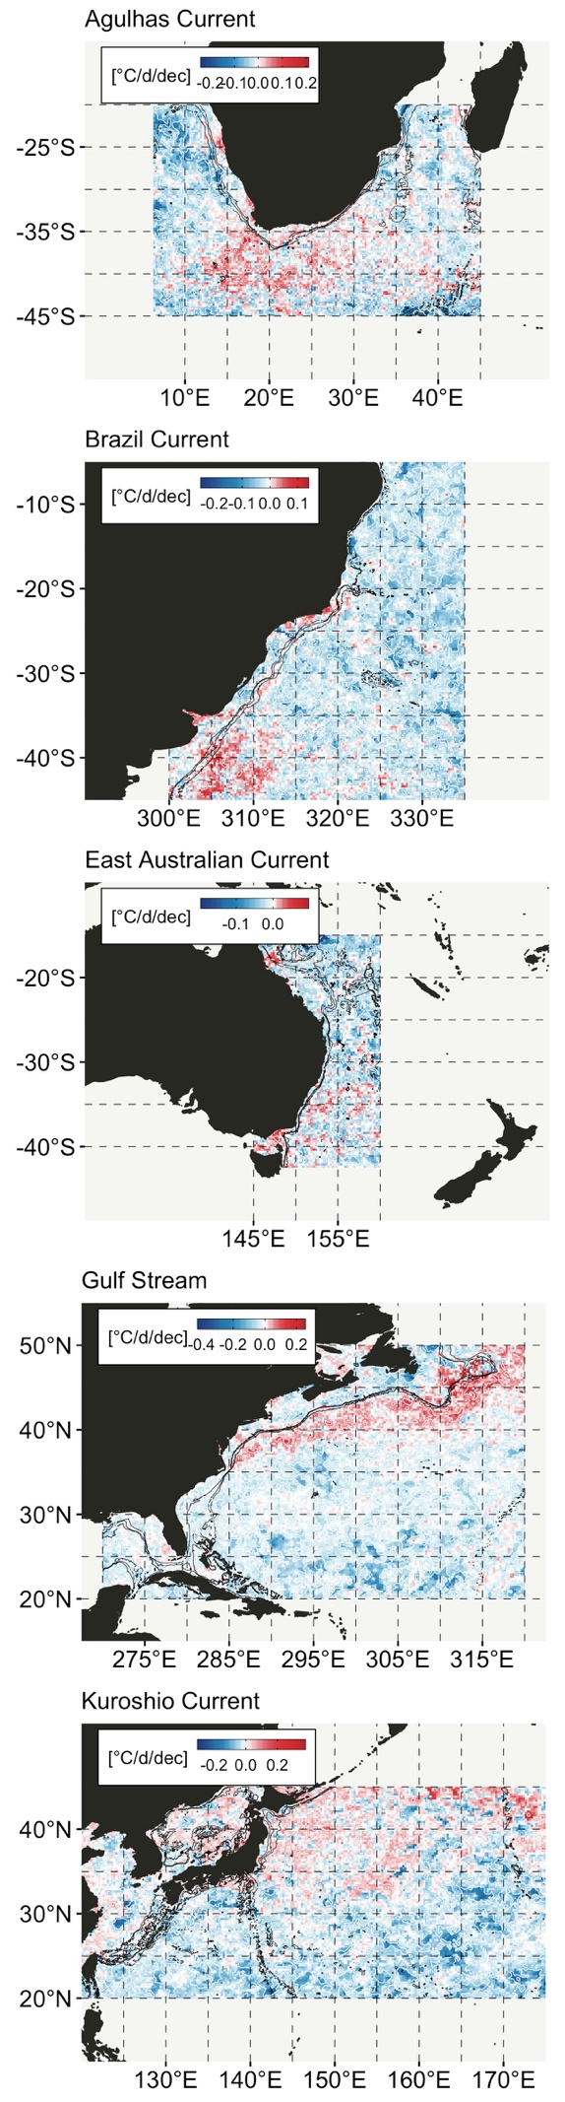**Figure 12.** *Trend in rate of onset* [°C/day/dec]. See Fig. 8 for further details. No interesting pattern is present in the rate of decline and this figure is therefore not shown.

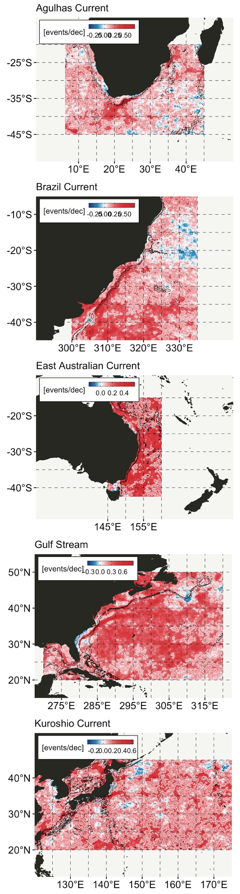**Figure 13.** *Trend in number of events per year* [events/yr/dec]. Trend estimated using a GLM (Poissan). See Fig. 8 for further details. No interesting pattern is present in the rate of decline.

The rest of the analysis focuses on the three most intense (*mean intensity*) events detected in the areas marked with black squares on the maps (Gulf Stream only for now). These events are defined by these start, end, and peak event dates:

**date_start date_peak date_end**

[1,] "2014-03-01" "2014-03-24" "2014-04-29"

[2,] "2014-11-23" "2014-12-21" "2015-02-24"

[3,] "2018-03-05" "2018-04-05" "2018-05-02"

[4,] "2017-10-30" "2017-12-12" "2018-02-24"

[5,] "1995-02-24" "1995-03-08" "1995-04-07"

I’ll show plots for the top three of these, with the plots ‘centred’ on the date on the peak intensity for the Gulf Stream. Similar images are available in the shared Google Drive folder for the Agulhas, Brazil, East Australian, and Kuroshio Currents. The dates of the ‘thermal event snapshots’ are contained within the file names.

***Cold- and warm-core eddies***

In the northern [southern] hemisphere, a cold-core eddy is a ring of WBC water that flows counterclockwise [clockwise] around a cold, less salty mass of water.

Southern hemisphere meanders shed anticyclonic eddies--called anticyclonic retroflection eddies. Smaller cyclonic and anticyclonic eddies are shed elsewhere from the southern hemisphere WBCs.

Question: how do we determine how often the current loops and pinches off from the average current path?

compare for top three events:

1. chl-a conc during event with chl-a conc prior to event

2. chl-a conc during event with chl-a conc post event

compare for events of increasingly longer durations:

1. chl-a conc during event with chl-a conc prior to event

2. chl-a conc during event with chl-a conc post event

since both cyclonic and anticyclonic eddies are being formed from the WBCs, compare the chl-a content of cyclonic vs. anticyclonic eddies:

1. chl-a conc during event with chl-a conc prior to event

2. chl-a conc during event with chl-a conc post event

What about eddy amplitude, radius, and rotation speed?

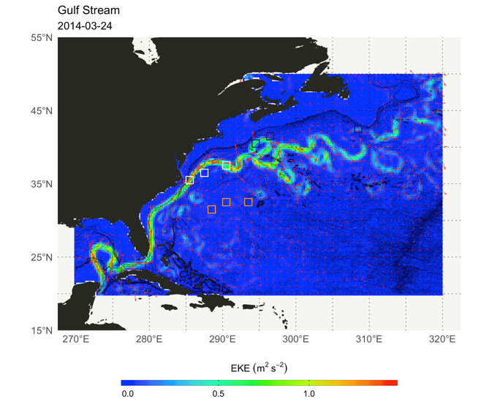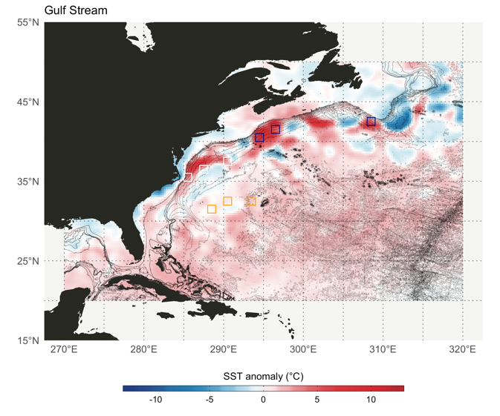

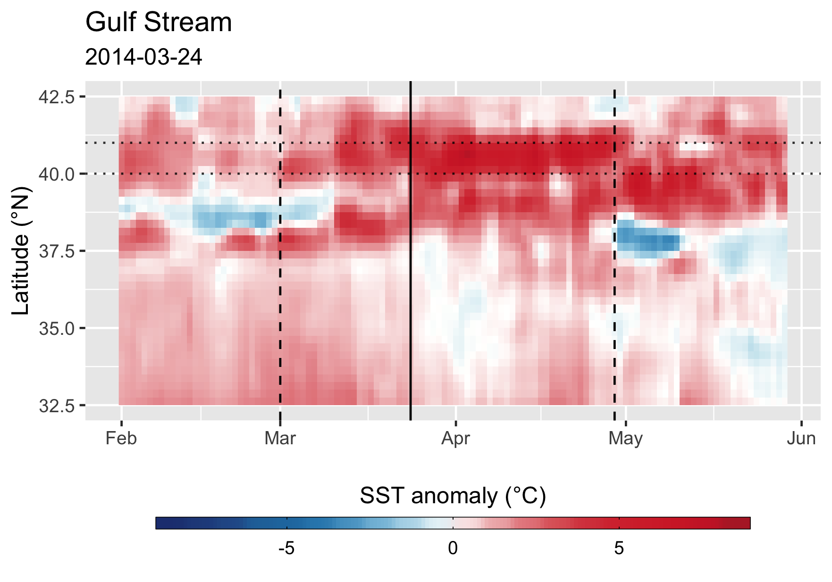

**Figure 14 a-c.** *(a, top left)* The mean current path on 2014-03-24, at which time the peak intensity of the most intense thermal event was detected in the Gulf Stream region. *(b, top right)* The SST anomaly relative to the 1982 to 2011 annual cycle (365-day) climatology, showing areas of most extreme anomalies co-located with areas where meanders deviate to the north of the average current trajectory (see ‘Combo_figs3.png’ left column for average current path). *(c, bottom)* Hovmöller plot of the extreme thermal event that started on 2014-03-01, peaked on 2014-03-24, and ended on 2014-04-29, as indicated by the left dashed, middle solid, and right dashed lines, respectively. The parallel horizontal dotted lines mark the left-most black box that is clearly visible in (b), situated over the area 40-41°N, 294-295°E, and which marks the location where the intense thermal anomaly coincides in space with the northwards meander of the Gulf Stream.

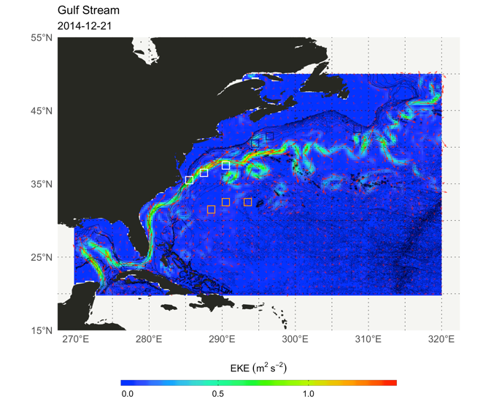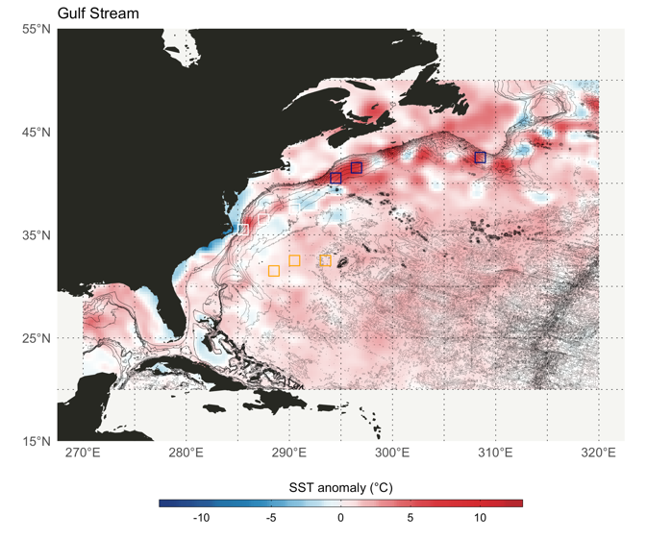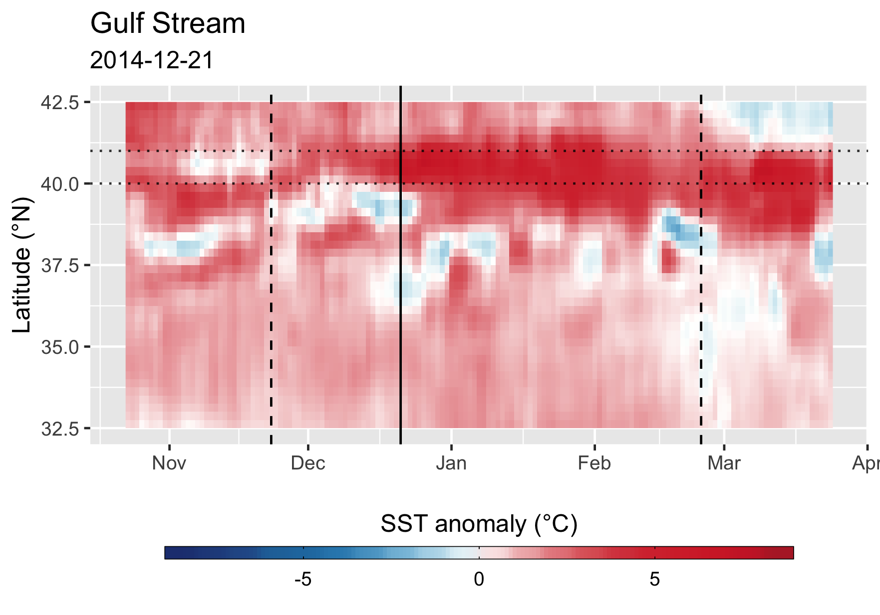

**Figure 15 a-c.** As Fig. 14 a-c, but showing the extreme thermal event that started on 2014-11-23, peaked on 2014-12-21, and ended on 2015-02-24.

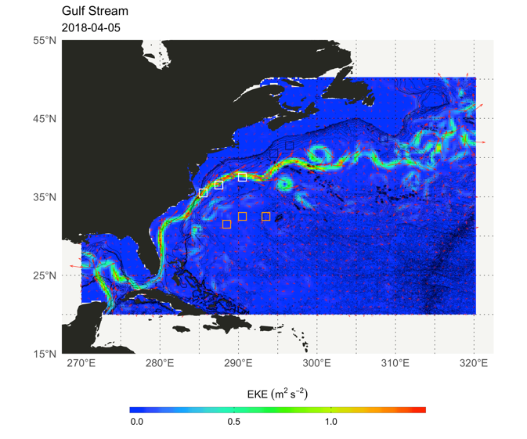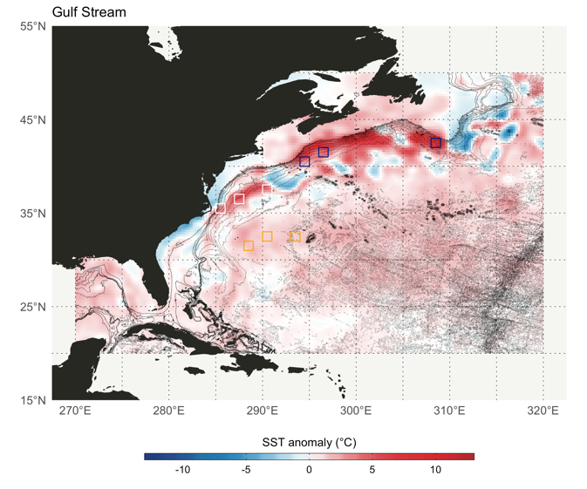

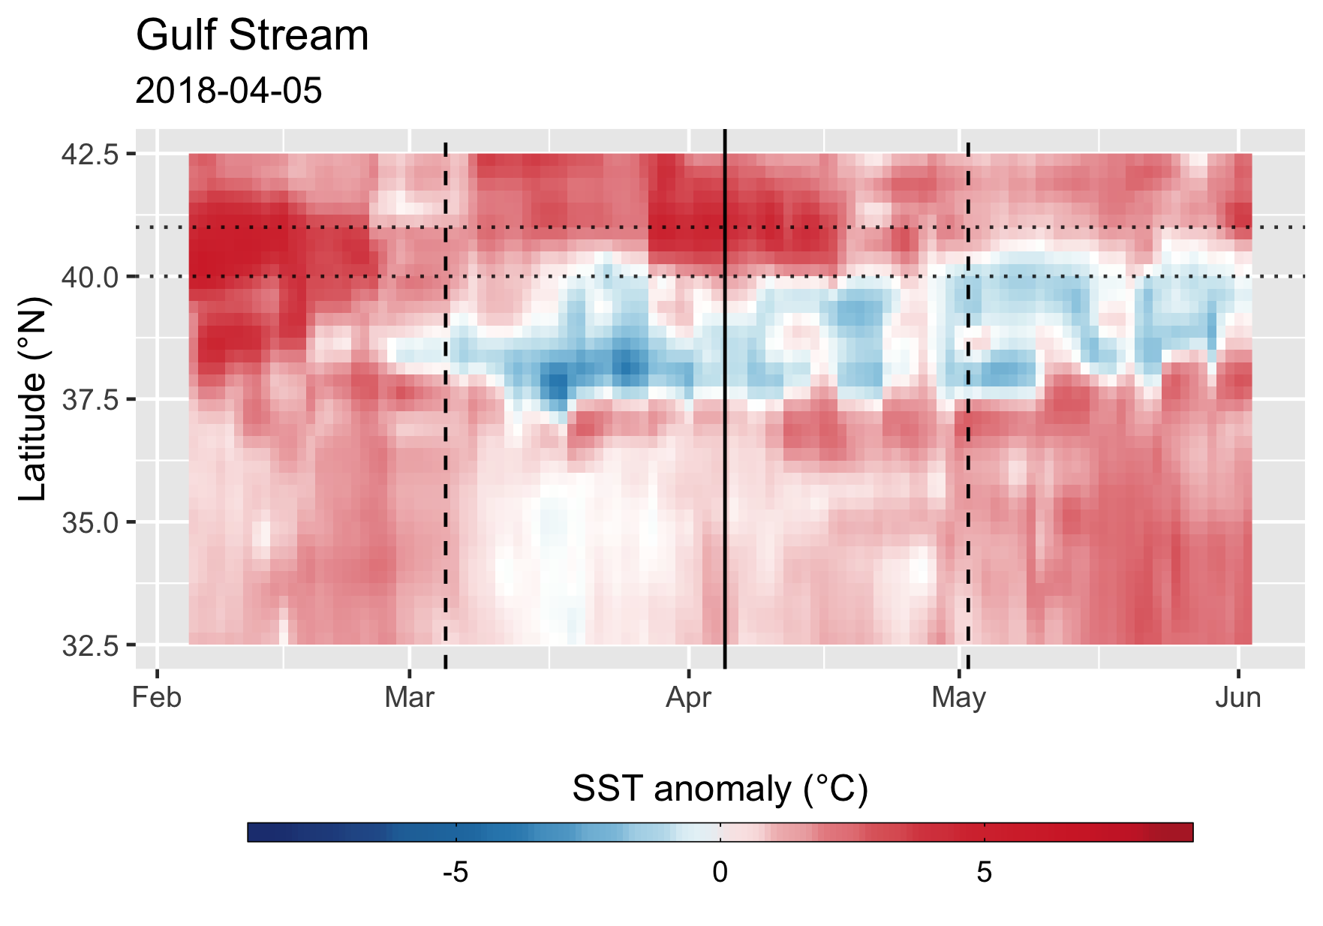

**Figure 16 a-c.** As Fig. 14 a-c, but showing the extreme thermal event that started on 2018-03-05, peaked on 2018-04-05, and ended on 2018-05-02.

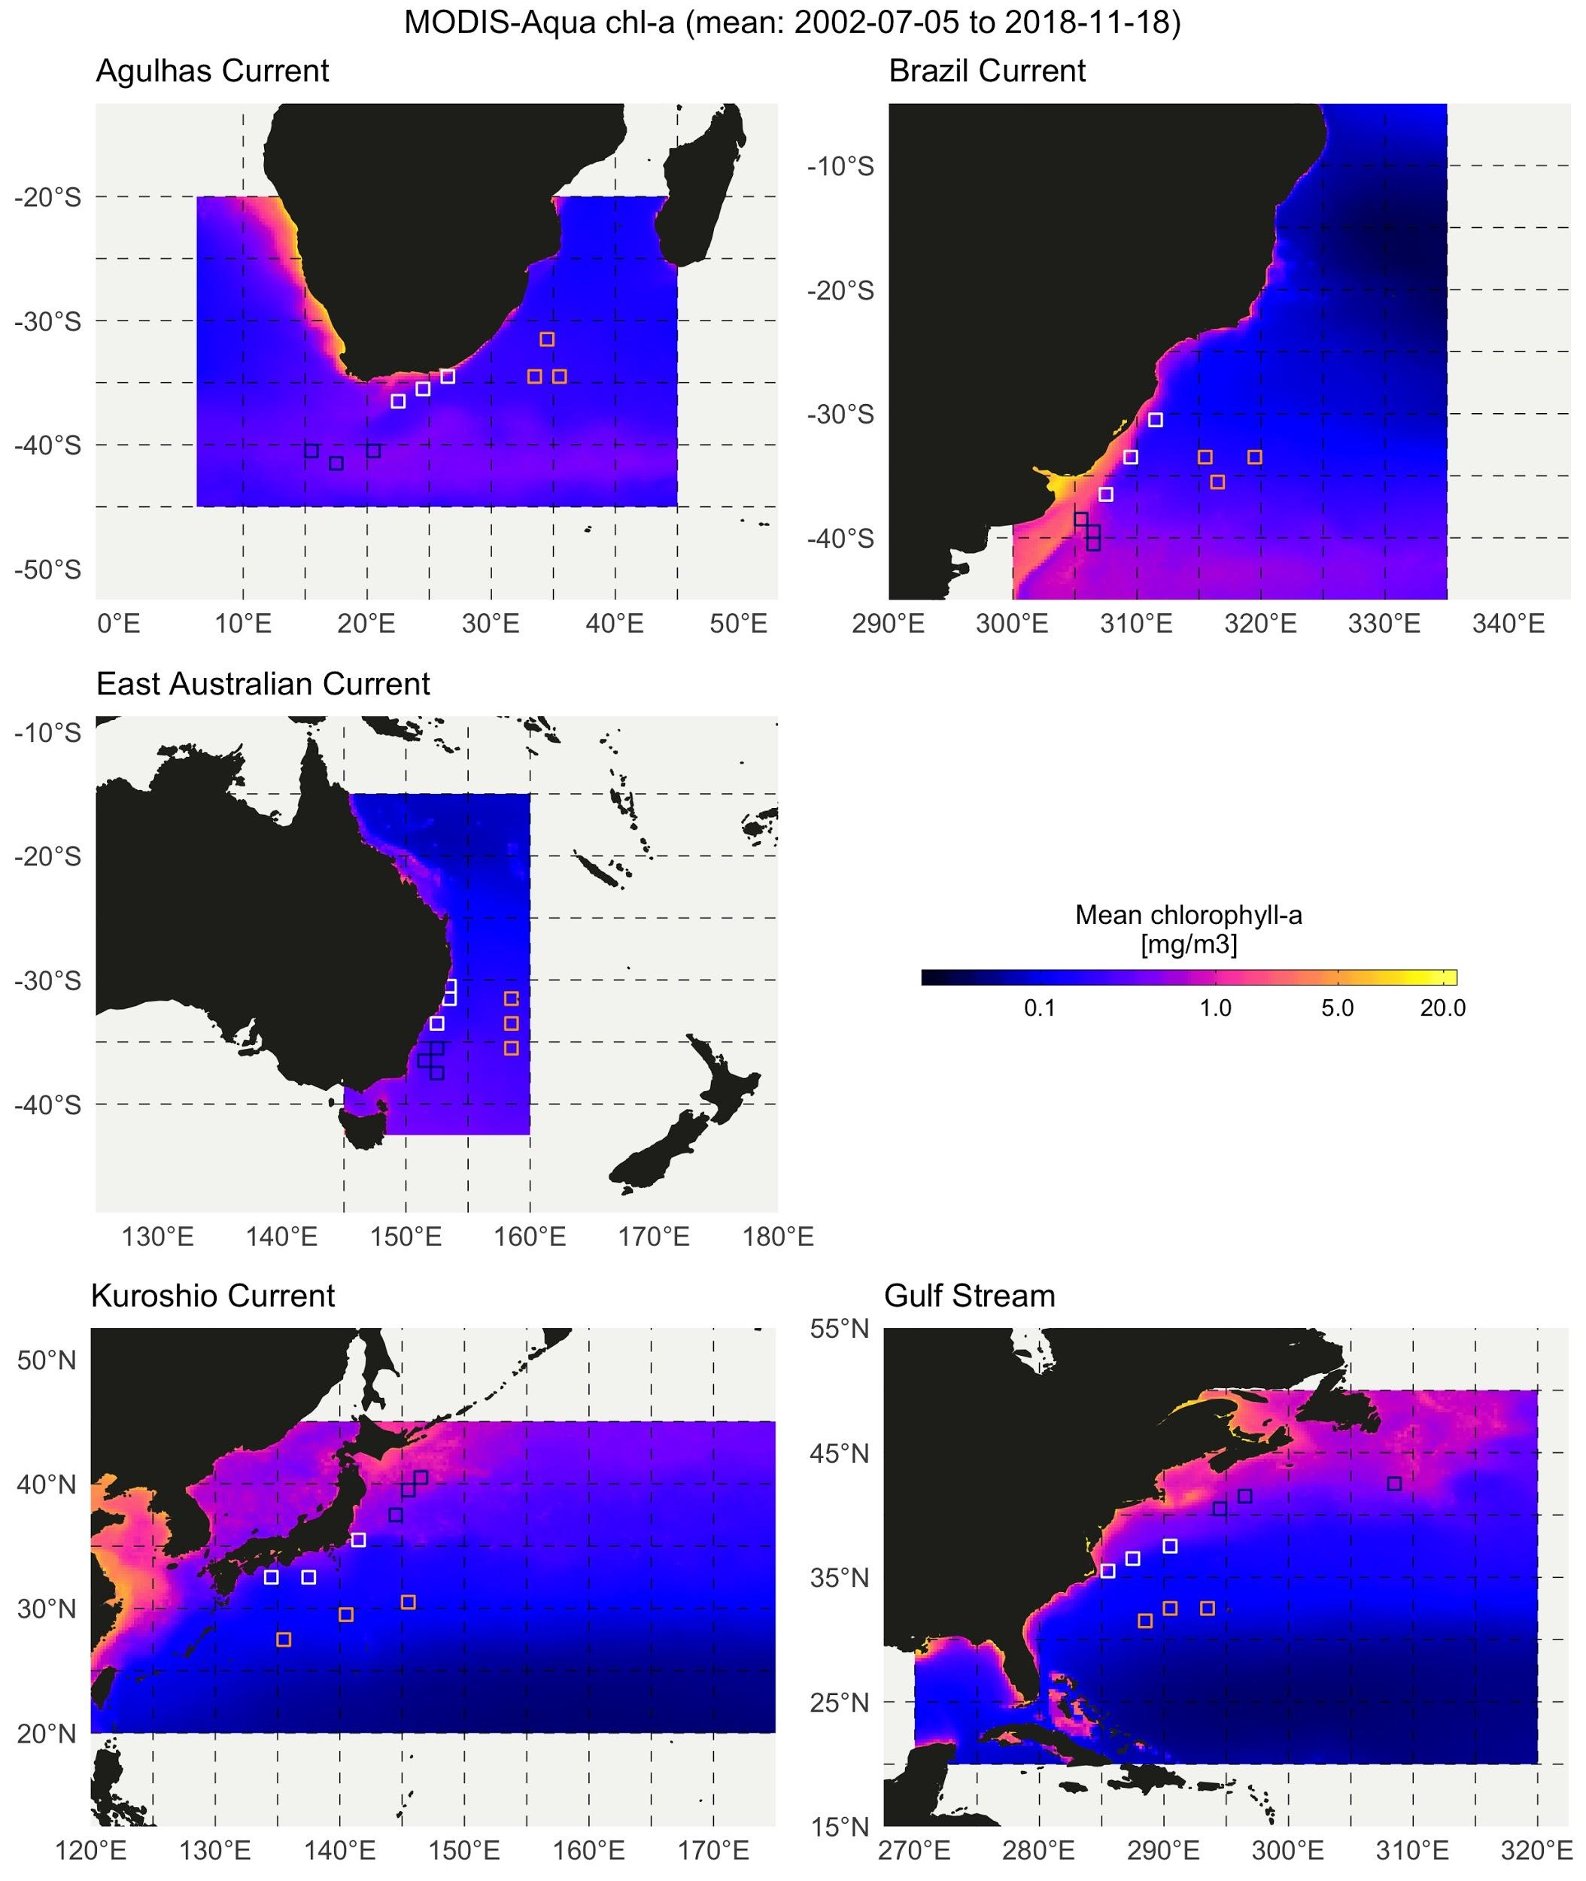

**Figure 17.** Regional summaries of MODIS Aqua *mean chlorophyll-*a *concentration* [mg/m3] calculated as the mean over the period 2002-07-05 to 2018-11-18 from 6 km pixel, 8-day composites. Data regridded to the 0.25° OISST spatial grid prior to plotting and further analysis.

*Note:* calculating monthly means for use in trend calculations might be problematic if starting from 8-day composite data… daily better, even with larger proportion of NAs?

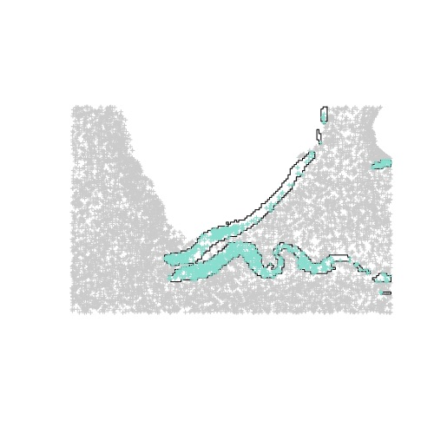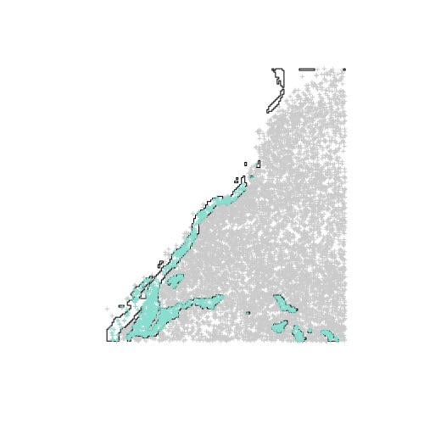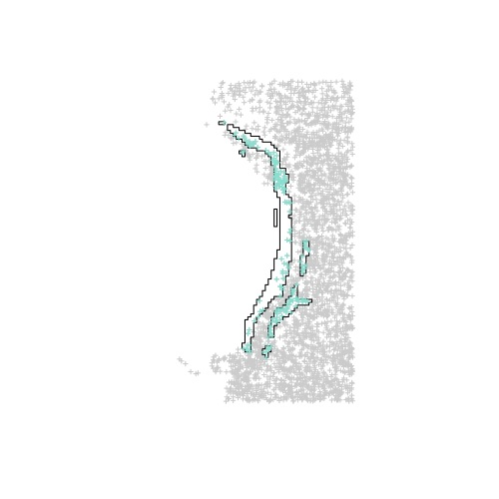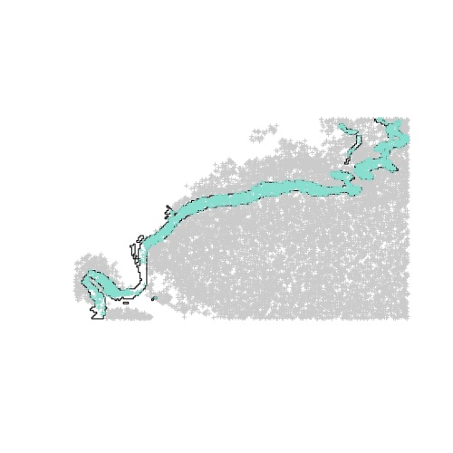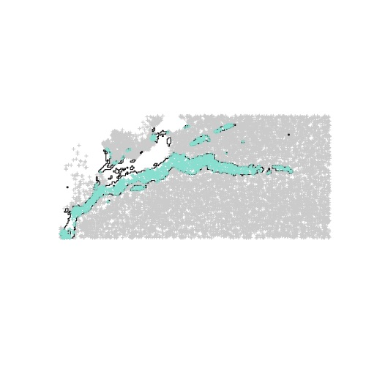

**Figure 18.** Masks created from the regions of high (≥90th percentile) MKE (as in Figure 1 and left column, ‘Combo_figs3.png’), which were used define the region from within which the eddies originate that form the region of high EKE (*i.e.* second column from the left in ‘Combo_figs3.png’). These eddy ‘fields’ are visible in ‘Combo_figs3.png’ in the third column from the left.